DR400-D Portable FPV Detection and Video Transmission Capture Device

Technical Specifications

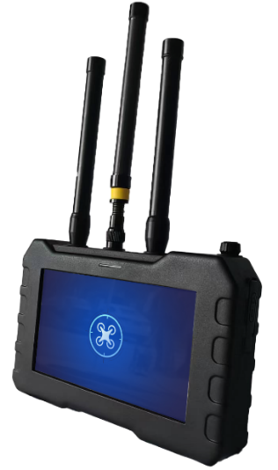

Product Model： | DR400-D
Version： | V3.1
Date： | Aug. 2025

Table of Contents
1. Introduction 3
2. Device Overview 3
2.1 Device Name 3
2.2 Device Model 3
2.3 Device Usage 3
2.4 Device Features and Functions 4
3. Device Technical Parameters 4
4. Device Structure and Components 5
5. Packaging and equipment configuration list 6
5.1. Device List 6
5.2 .Device Security Protection 8
6. Device Maintenance 8

1. Introduction
With the rapid development and popularization of drone technology, drones have shown great application potential in aerial photography, agriculture, rescue, security and other fields, but at the same time they have also brought increasingly serious safety risks. Incidents such as illegal intrusions, malicious reconnaissance, and privacy violations occur frequently, posing serious threats to national security, public safety, and personal privacy. Therefore, the development of efficient and advanced drone jamming technology has become an urgent need to maintain airspace security and ensure social stability.

2. Device Overview
The portable FPV detection and video transmission capture device integrates detection, video interception, and video storage into one system. It features full-band detection, FPV analog video transmission detection, video interception, display control, and video storage functions. In complex electromagnetic environments, it can accurately identify quadcopters, fixed-wing drones, DIY models, and FPV drones, and provide sound, light, and vibration alarms. This device is suitable for scenarios such as routine patrols, critical target protection, unit-level operations, and investigation and evidence collection.

2.1 Device Name
DR400-D portable FPV detection and video transmission capture device

2.2 Device Model
DR400-D

2.3 Device Usage
Incidents such as illegal intrusions, malicious reconnaissance, and privacy violations occur frequently through drones, posing a serious threat to national security, public safety, and personal privacy. Therefore, the development of efficient and portable drone countermeasures technology has become an urgent need to maintain airspace security and ensure social stability.

2.4 Device Features and Functions
- Full-band detection: Capable of detecting the entire 70 MHz–6.2 GHz range.
- Comprehensive FPV band coverage: Fully supports analog video transmission detection within the 500 MHz–6 GHz range.
- Video interception: Intercepts all analog video transmissions, allowing "first-person view" analysis of FPV intrusion targets and real-time dynamics.
- Video storage: Real-time captured video can be stored as evidence.
- Team collaboration: Features a 1+N mode with master-slave device design, enabling alarm linkage and coordinated operations (wrist watch is optional).
- Device Technical Parameters
Number | Name | Specifications
 | Identification types | Supports mainstream drones such as DJI, Autel, Hubsan, as well as FPV racing drones and DIY drones
 | Frequency range | Supports customizable scanning from 70 MHz to 6.2 GHz.  Default detection bands: 400 MHz, 800 MHz, 900 MHz, 1.2 GHz, 1.4 GHz, 2.4 GHz, 5.2 GHz, 5.8 GHz (other bands can be customized)
 | FPV video transmission detection | Supports detection of all analog video transmissions within the 500 MHz–6 GHz frequency range (user-customizable)
 | Detection radius | ≥ 1.5 km (line-of-sight, clean electromagnetic environment).
 | Video capture distance | ≥ 1.5 km (line-of-sight, clean electromagnetic environment).
 | Video storage capacity | ≥32 GB memory card, max to 256GB
 | Detection response time | ≤3s（8 bands）；≤5s（12 bands）
 | Battery life | ≥5s (both the screen brightness and the operating mode are in their default state)
 | Alarm modes | Sound, vibration, and light
 | Screen size | 7-inch touchscreen
 | Power supply | Powered by lithium battery
 | Battery capacity | 7000mAh
 | Device weight | ≤ 1.2kg
 | Device size | Length × Width × Height：212mm×137mm×41mm

4. Device Structure and Components
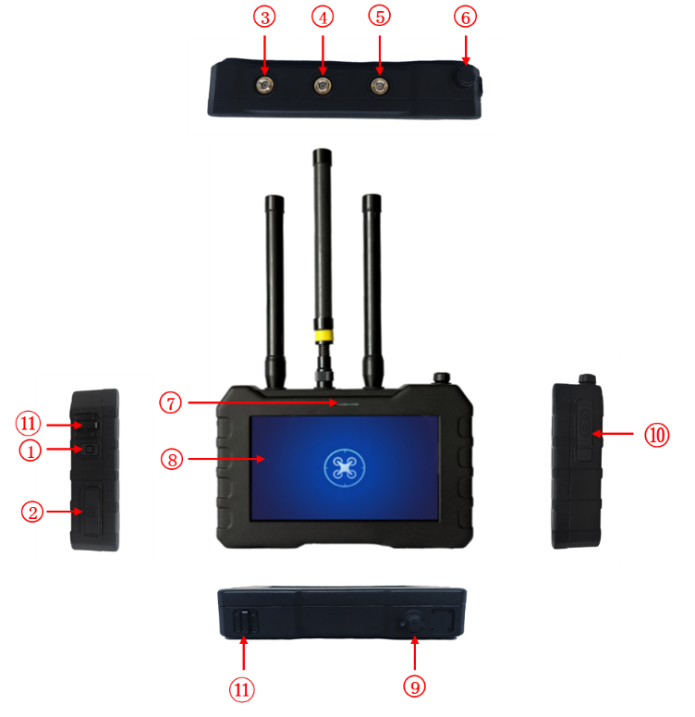
Figure 1 Device three views
No. | Name | Function
① | Function Button | One-key screen off function: press to turn off the screen, press again to turn it on.
② | SD Card Slot | Used for installing an SD memory card.
③ | Antenna SMA Connector | Used for installing a full-band image capture antenna.
④ | Antenna SMA Connector | Used for installing a 5.8G image capture antenna (yellow ring antenna).
⑤ | Antenna SMA Connector | Used for installing a full-band detection antenna to receive UAV signals for detection.
⑥ | Power Knob | Power switch / alarm volume adjustment (turn clockwise to power on/increase volume, counterclockwise to power off/decrease volume).
⑦ | Alarm Indicator Light | Warning or alarm light prompt after detecting a UAV. This function can be enabled or disabled in the settings (see subsequent button operation instructions).
⑧ | 7-inch Touch Display | Displays working status and detection results.
⑨ | Charging Port | Charging voltage: DC 8.4V / 2A.
⑩ | Headphone Jack / TYPE-C Upgrade Port | External 3.5mm headphone / model feature library upgrade port.
⑪ | Strap Buckle | Used for attaching a wrist strap.

5. Packaging and equipment configuration list

5.1. Device List
No. | Product Name | Product Picture | Quantity |  | Remarks
1 | Main Unit | 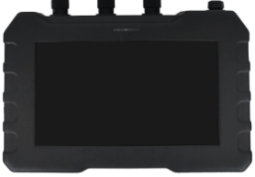 | 1 | Standard Configuration | With SD memory card
2 | 5.8 GHz Image Capture Antenna | 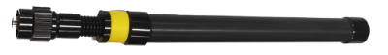 | 1 | Standard Configuration
3 | Full-band Antenna | 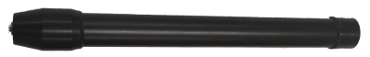 | 2 | Standard Configuration
4 | EU Standard 8.4V Charger | 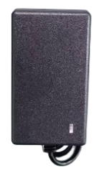 | 1 | Standard Configuration
5 | USB Data Cable | 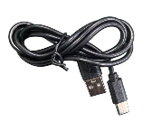 | 1 | Standard Configuration
6 | 3.5mm Headphones | 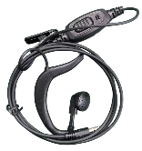 | 1 | Standard Configuration
7 | Packing Box | 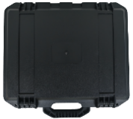 | 1 | Standard Configuration
8 | Card Reader | 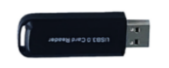 | 1 | Standard Configuration
9 | Wrist Strap | 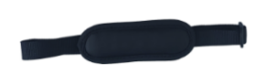 | 1 | Standard Configuration
10 | Shoulder Strap | 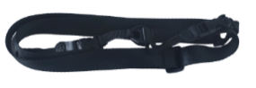 | 1 | Optional Configuration
11 | Detection Information Receiver Terminal | 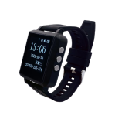 | 1 | Optional Configuration | With wrist watch charging cable
12 | USB Charger | 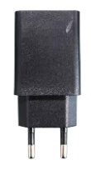 | 1 | Optional Configuration
13 | Full-band Spring Soft Antenna |  | 2 | Optional Configuration

5.2 .Device Security Protection
Aviation case：
Packaging size:Length 350mm* Width 300mm* Height 100mm

6. Device Maintenance
Power on the device regularly to check its status.

